Anagha Uppal

Dr. Robinson

SOC 233R

October 18, 2018

Reflection #1

I had the pleasure of reading a few reflection briefs before I started writing my own. I may not be able to think and write like you all, but I am absorbing as much or more from the pieces than the reading itself! Ryan, in his, spoke of the enduring relatability of Marx’s ideals, which I appreciated so much. Marx accurately assessed issues of labor in the 19th century in a way that no one else before him had been able to do, and because capitalism itself does not really change, those issues are still shudderingly relevant. Perhaps we can also consider how, and if, things have changed in modern society that demand or have produced a modified application of Marxism.

Marxism may have been taught less frequently in the past twenty or twenty-five years, but one of its central term, the bourgeois, itself receded from view even earlier, beginning in the late 1970s, (see Google Ngram figure below).

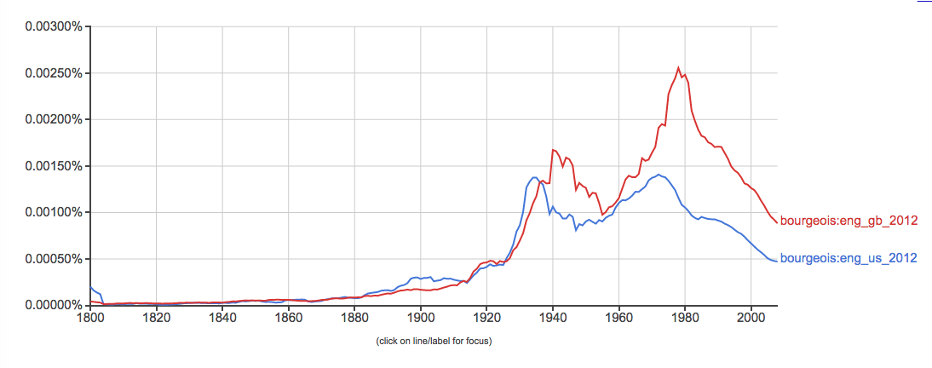

Furthermore, the cultural meaning of the term bourgeois has changed. Classically, it refers to ruling and landowning class in a capitalist society, it holds different (still negative). undertones today. It has come to imply a social climber, one “whose way of thinking is socially and culturally determined by their economic materialism and philistinism” (Wikipedia).

All of this may represent a shift in the positioning of the class structure that would be critical to understanding Marxism today. How do these linguistic shifts relate to the disappearance of the middle class? Is the implicit transition to condemning modern aristocracy (the ruling 1%) as opposed to the middle class a sound one? Who is the working class in today’s context? According to Marx, conservative socialists “violently oppose all political action on the part of the working class; such action, according to them, can only result from blind unbelief in the new Gospel” (59). Is the prototypical Trump voter (or Brexit voter or Bolsonaro voter) a part of this working class, and is their voting behavior a form of political action? If so, is speaking ill of these voters and undereducated rural workers (whose actions may not not align with the interests of minorities) a form of democratic inclusion for the minority or of violent opposition on the part of a conservative socialist?

And once we understand the issues of today’s class system, who will initiate the revolution dreamed of? Marx sweeps aside the middle class as reactionary and conservative, instead affirming the proletariat as industry’s “special and essential product” who “alone is a really revolutionary class” (20-21). The emphasis reminds me of one of common Theater of the Oppressed exercise used in team-building groups. In this interactive learning tool, one participant places four chairs in a desired configuration, and the rest of the group names which chairs it believes to be the most powerful. Over a couple of iterations, participants usually begin to believe that the chair furthermost back or lowest and closest to the ground is the core of the society and the the most powerful. A century later, George Orwell wrote: “The aim of the High is to remain where they are. The aim of the Middle is to change places with the High…. From the point of view of the Low, no historic change has ever meant much more than a change in the name of their masters” (1984). Is the conflict here simply one of optimism? At this stage, who is the Low, Middle and High and who will change places?